**Assignment**

**Advance JS**

Module-1:

**Q1. Write a program to Show an alert**

**ANS.** 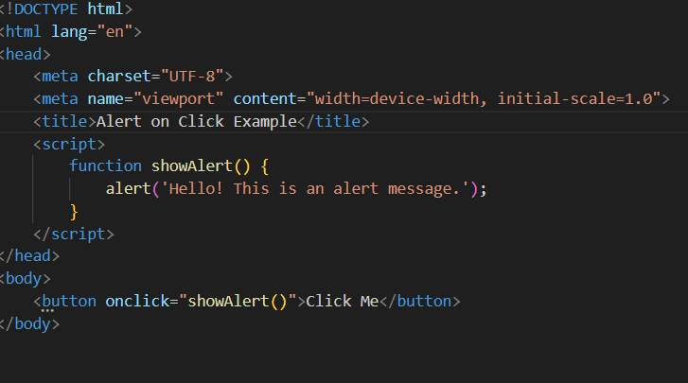

**Q2. What will be the result for these expressions?**

**Ans.**

1. 5 > 4 -True

2. "apple" > "pineapple" - false

3. "2" > "12" - true

4. undefined == null - true

5. undefined === null - false

6. null == "\n0\n" - false

7. null === +"\n0\n" - false

**Q3. Will alert be shown? if ("0") { alert( 'Hello'); }**

**ANS.** Yes, the alert will be shown.

**Q4. What is the code below going to output? alert( null || 2 || undefined );**

**ANS.** The code will output 2.

**Q5. The following function returns true if the parameter age is greater than 18. Otherwise it asks for a confirmation and returns its result:function checkAge(age) { else { } } if (age> 18) { return true; } // ...return confirm (‘did parents allow you?');**

**ANS.** 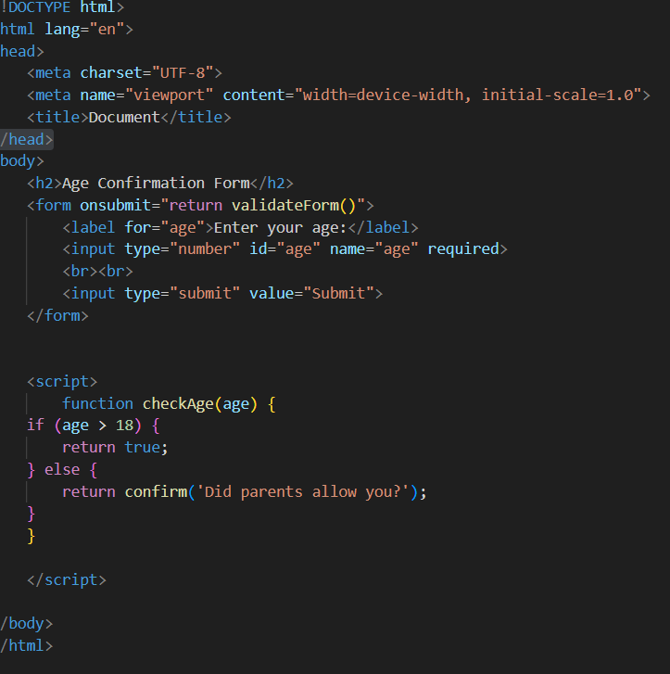

**Q6. Replace Function Expressions with arrow functions in the code below:Function ask(question, yes, no) { if (confirm(question))y es(); elseno(); } ask("Do you agree?",function() { alert("You agreed."); }, function() { alert("Youcanceled the execution."); } }**

**ANS.**

Module 2:

Q1. Write the code, one line for each action: a) Create an empty

object user.

b) Add the property name with the value John.

c) Add the property surname with the value Smith.

d) Change the value of the name to Pete.

e) Remove the property name from the object.

ANS.

a) Create an empty object user.

let user = {};

b) Add the property name with the value John.

user.name = "John";

c) Add the property surname with the value Smith.

user.surname = "Smith";

d) Change the value of the name to Pete.

user.name = "Pete";

e) Remove the property name from the object.

delete user.name;

**Q2. Is array copied? let fruits = ["Apples", "Pear", "Orange"]; // push a new value into the "copy"let shoppingCart = fruits; shoppingCart.push("Banana"); // what's in fruits? alert( fruits.length ); // ?**

**ANS.** No, the array is not copied. When you assign fruits to shoppingCart, you are creating a new reference to the same array. Both fruits and shoppingCart point to the same array in memory.

So, when you push a new value into shoppingCart, you are modifying the original array. Therefore, fruits will also be updated.

**Q3. Map to names let john = { name: "John", age: 25 }; let pete = { name: "Pete", age: 30 }; letmary = { name: "Mary", age: 28 }; let users = [ john, pete, mary ]; let names = /* ... your code */ alert( names ); // John, Pete, Mary**

**ANS.** 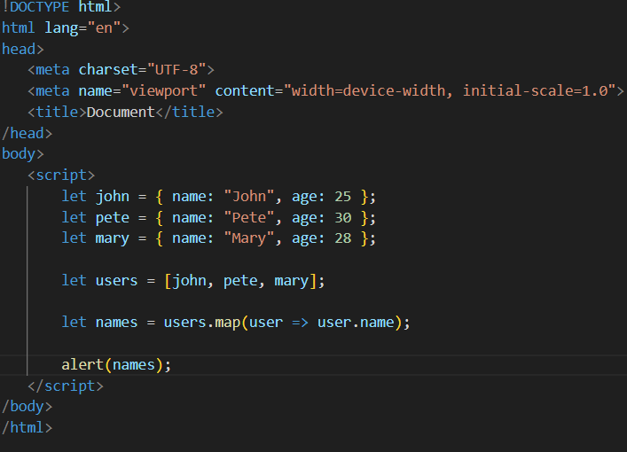

**Q4. Map to objects let john = { name: "John", surname: "Smith", id: 1 }; let pete = { name: "Pete", surname: "Hunt", id: 2 }; let mary = { name: "Mary", surname: "Key", id: 3 }; let users = [ john, pete, mary ]; let usersMapped = /* ... yourcode ... */ /* usersMapped = [ { fullName: "John Smith", id: 1 }, { fullName: "Pete Hunt", id: 2 }, { fullName: "Mary Key", id: 3 } ] */ alert( usersMapped[0].id ) // 1 alert( usersMapped[0].fullName ) // JohnSmith**

**ANS.** 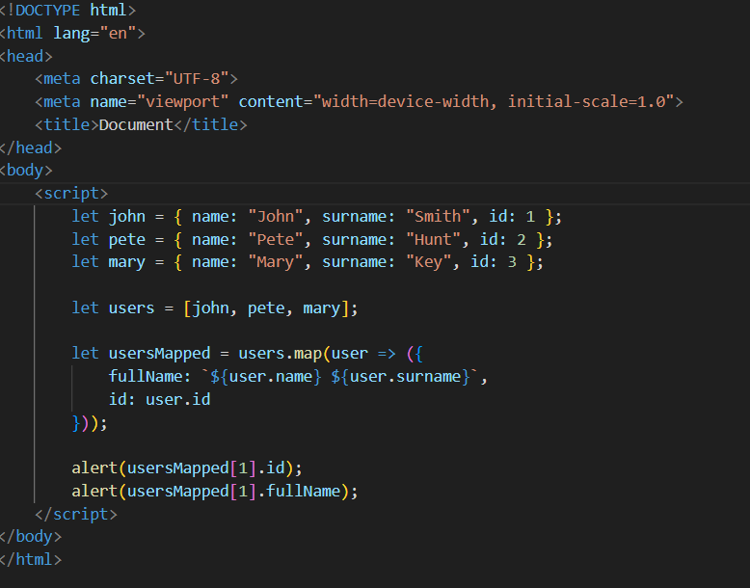

**Q5. Sum the properties There is a salaries object with arbitrary number of salaries. Write the function sumSalaries(salaries) that returns the sum of all salaries using Object.values and the for..of loop.If salaries is empty, then the result mustbe 0. let salaries = { "John": 100, "Pete": 300, "Mary": 250 }; alert( sumSalaries(salaries) ); // 650**

**ANS.** 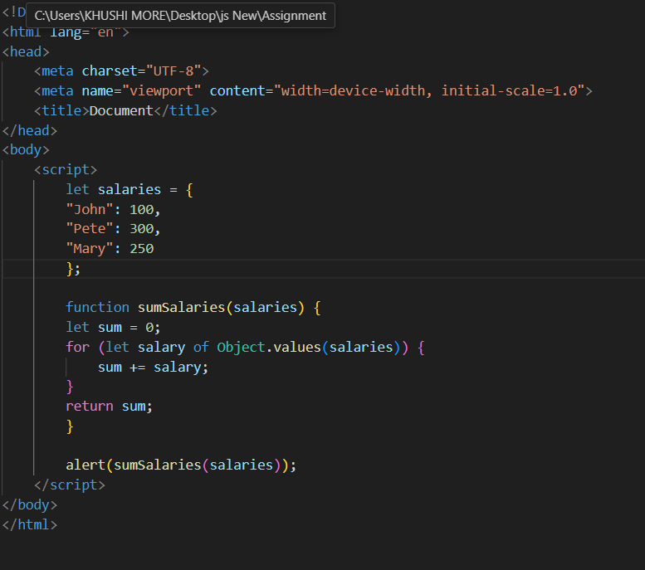

**Q6. Destructuring assignment We have an object: Write the Destructuringassignment that reads: a) Name property into the variable name. b) Year’s property into the variable age. c) isAdmin property into the variable isAdmin (false, if no such property) d) let user = { name: "John", years: 30};**

**ANS.**

let user = { name: "John", years: 30 };

let { name, years: age, isAdmin = false } = user;

console.log(name); // John

console.log(age); // 30

console.log(isAdmin); // false

**Q7. Turn the object into JSON and back Turn the user into JSON and then read itback into another variable. user = { name: "John Smith", age: 35};**

**ANS.** 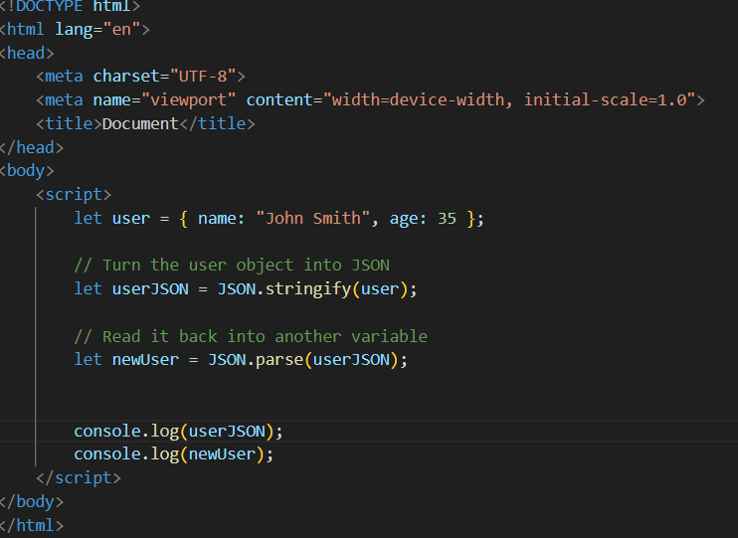

Module-3:

**Q1. Create a program to hide/show the password.**

**ANS.** 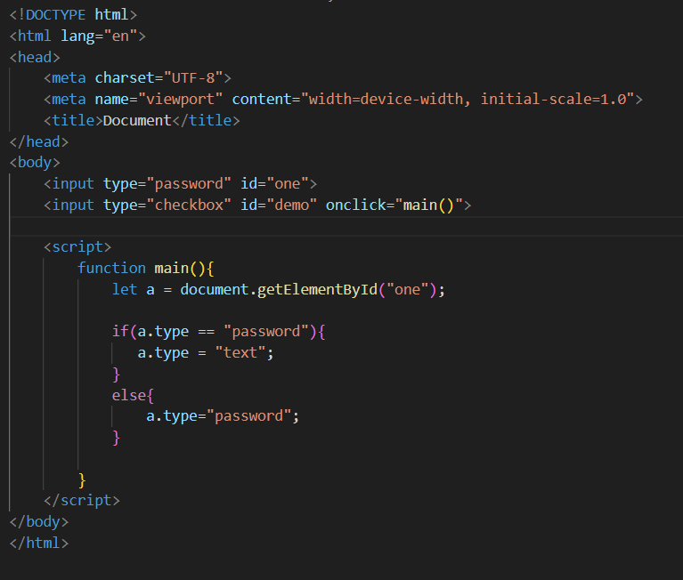

**Q2. Create a program that will select all the classes and loop over and whenever iclick the button the alert should show**

**ANS.** 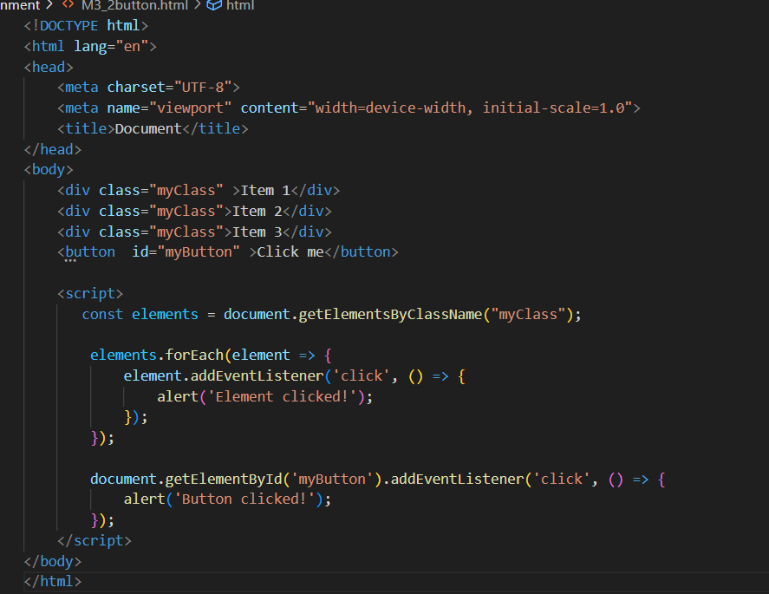

**Q3. Create a responsive header using proper JavaScript**

**ANS.** 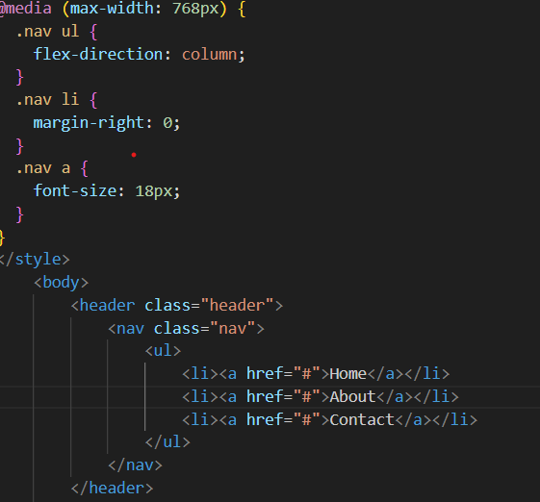

**Q4. Create a form and validate using JavaScript**

**ANS**. 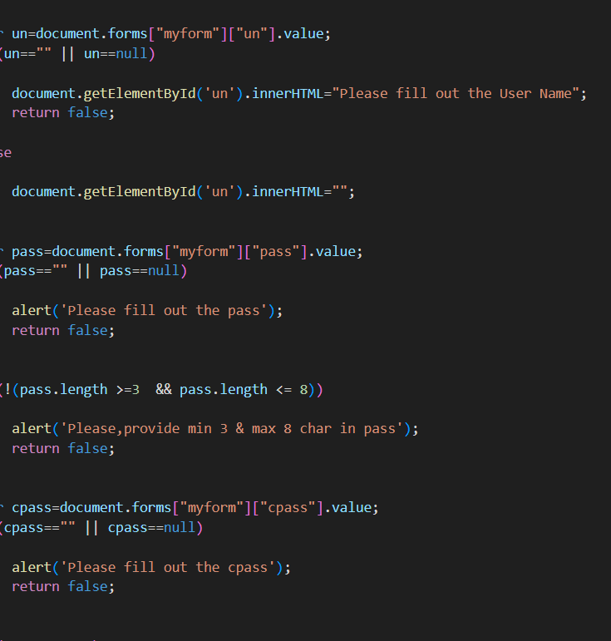

**Q5. Create a modal box using css and Js with three buttons**

**ANS**. 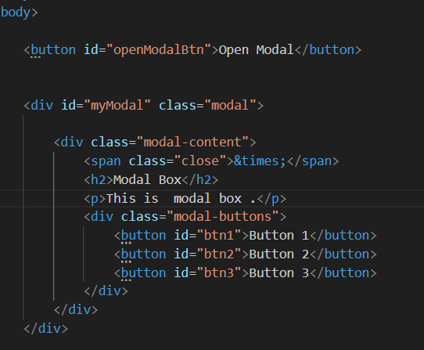

**Q6. Use external js library to show slider**

**ANS.**

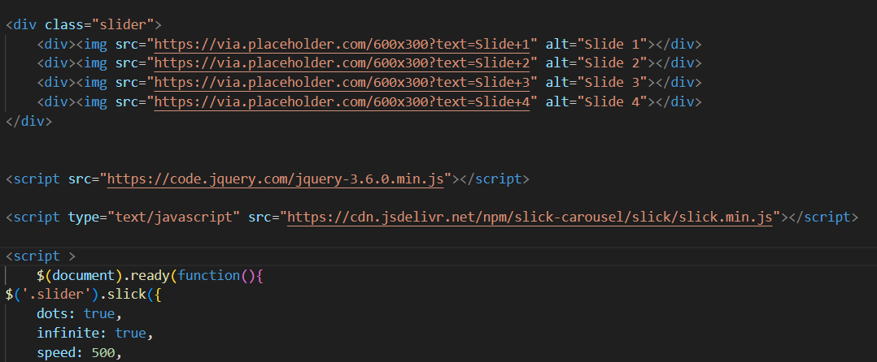

**Q7. Prevent the browser when i click the form submit button**

**ANS**. 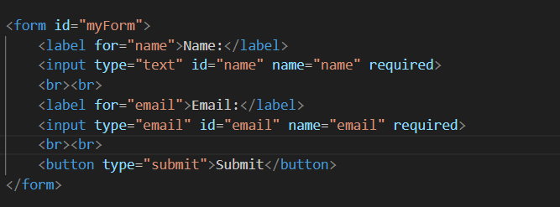

**Module-4:**

**Q1. What is JSON.**

**ANS.** JSON stands for JavaScript Object Notation

JSON is a lightweight format for storing and transporting data

JSON is often used when data is sent from a server to a web page

JSON is "self-describing" and easy to understand

Q2. What is Promise

ANS. A JavaScript Promise object can be:

* Pending
* Fulfilled
* Rejected

The Promise object supports two properties: state and result.

While a Promise object is "pending" (working), the result is undefined.

When a Promise object is "fulfilled", the result is a value.

When a Promise object is "rejected", the result is an error object.

Q3. Write a program of promises and handle that promises also • Use fetch method for calling an api https://fakestoreapi.com/products

**ANS**. 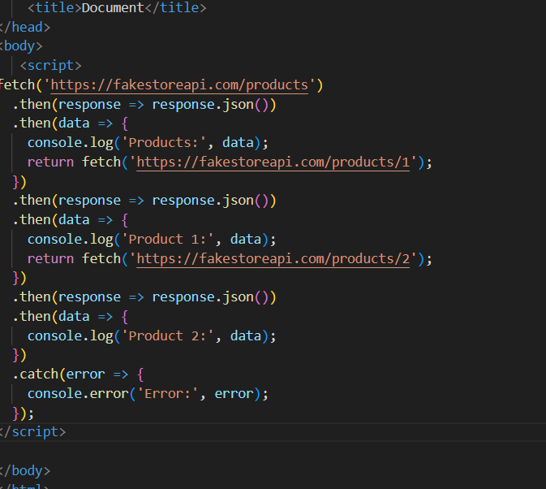

**Q4. Display all the product from the api in your HTML page**

**ANS**. 